

Minecraft XBLA 1.8.2 Update

TABLE OF CONTENTS

Tutorial/Trial World Changes & Additions 2
Tutorial Changes & Additions 2
Trial World (Beyond Tutorial Area) Changes & Additions 2
New Seed 2
New Features 2
Tutorial Map Changes 2
Music Discs Hunt 3
How To Play Additions 4
Creative Mode 4
Basics 4
HUD 4
What’s New 4
Controls & HUD Changes 5
Sprinting 5
Flying 5
What’s This? 5
Food Bar 5
Creative Mode 6
Creative Mode Interface 6
Food Bar 7
Create World 8
Terrain Generation Features 8
NPC Villages 8
Java Version 8
Changes required for the Xbox version 8
Stongholds 9
Java version 9
Changes required for the Xbox version 9
Abandoned Mineshafts 10
Java Version 10
Changes Required for the Xbox Version 10
Ravines 11
Java Version 11
Superflat Land 12
Bonus Chest 12
Load World 13
Host Options 14
Moving things forward from later updates 15
Snow 15
Superflat Land 15
Bonus Chest 15
Mining Changes 15
Mushroom Stew 15
Features changes 15
New Music discs 15
Apple dropping from leaf block 16
New sound effects (the “Sound Update”) 16
Miscellaneous Changes 17
Removing from 1.8.2 18
Experience Points Bar and Experience Points 18

Change Table

Change | Who | Date
Initial Doc | PB | 17/07/12

Tutorial/Trial World Changes & Additions

We’ll be replacing the whole world in the tutorial in order to introduce a level with all the new structures (ravine, village, mineshaft & Stronghold), and new materials. Instead of being a save file load for the tutorial, it will now be a create world with a seed giving all the features in a world, and then the previous tutorial area and features will be transplanted into this level as part of the post processing stage.

Tutorial Changes & Additions

We’ll add a section on sprinting to the end of the basic movement tutorial, and a section on eating/the food bar.

Trial World (Beyond Tutorial Area) Changes & Additions

We have found the secrets that we’ve put in the trial area go down very well, so we’ve implemented a system to make these more trackable. We’ll be removing all the secrets from a previous TU when we release a new one, and replacing with the 12 Music Discs in chests for the players to find.

New Seed
The world seed is now - 6173462

New Features
The Tutorial world includes features created by the new world generation changes.
Ravine – X: 114, Y: 63, Z: -223
Villages – X: -156, Y: 70, Z: -227
Mineshaft – X: -129, Y: 37, Z:-256
Swamps – X: -1, Y: 64, Z: -283
Strongholds – X: 92, Y: 42, Z: -123

Tutorial Map Changes

Location Changes
Castle - X: -37, Y: 83, Z: -41
Piston Bridge – X: -37, Y: 83, Z: -41
Nether Portal – X: 58, Y: 68, Z: -100
Mine cart Tutorial – X: -139, Y: 67, Z: -36

Music Discs Hunt

The tutorial world has 12 secret chests with one of each of the twelve different music discs in each chest, along with some other items.

Secret Chest Positions

1 – Tutorial Exit – X: -130, Y: 67, Z: -48
2 – Village Well – X: -195, Y: 56, Z: -36
3 –Castle Portal Room–X: 36, Y: 82, Z: -61
4 – Castle Bedroom – X: 11, Y: 88, Z: -22
5 – Castle Window - X: -134, Y: 70, Z: -45
6 – Remote Island - X: 267, Y: 65, Z: 327
7 – Treehouse - X: 174, Y: 85, Z: -170
8 – Mountain Top - X: 40, Y: 114, Z: -100
9 – Desert Village – X: -152, Y: 78, Z: -230
10 – South Village – X: 94, Y: 74, Z: 295
11 – Minecraft Sign - X: -147, Y: 89, Z: -33
12 – Central Village - X: -189, Y: 74, Z: 39

How To Play Additions

Creative Mode

We’ll add in a description for the Creative Mode interface, and flying when in creative mode.

Basics

We’ll add a description for sprinting and flying.

HUD

We’ll add a description for the food bar.

What’s New

The “What’s New” section will be changed to reflect all the 1.8.2 features.

Controls & HUD Changes

Sprinting

We’ll add in the sprint control on double pushing the left stick. We’ll display the small animated character in the top left of the screen while sprinting (just like with the crouch control). We’ll also remove the collision-while-sprinting stopping the character from sprinting.

Flying

We’ll add in the flying control on double jumping in Creative Mode (toggle). We’ll display the small animated character in the top left of the screen while flying (just like with the crouch control). We’ll also add the ability to Sprint while Flying.

What’s This?

In the inventory type menus, we’ve moved the What’s This tooltip to RT from RB due to the need to have What’s This in the Creative menu which needs to have RB/LB for moving groups.

Food Bar

The HUD menu will have the food bar added.

Creative Mode

Achievements will be disabled in Creative Mode and in Survival Mode if the map loaded has ever been saved in Creative Mode.

The player will be able to fly in creative mode by double jumping to toggle flight. We’ll display the small character in the top left of the screen to show the player being in flying mode.
Mobs (Creepers, etc.) will be made passive when in Creative mode to avoid damage to the player’s creations.

Creative Mode Interface

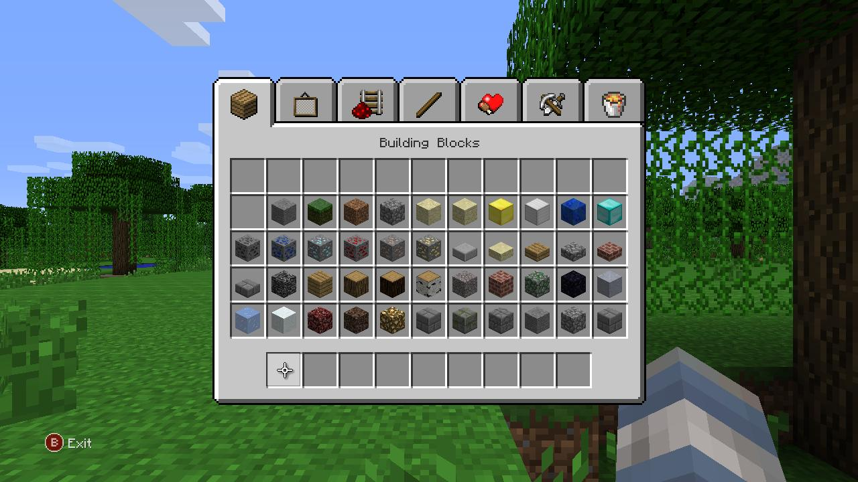

The Creative Mode interface will resemble the Java version, with group tabs along the top, and actions similar to the inventory interface. When an item is selected from the grouped items, the cursor will automatically move it over a quick select slot (starting with the first available empty slot) to avoid the player having to navigate there.

Food Bar

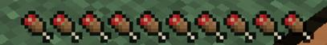

The Food Bar will be added, along with the requirement to replenish it regularly by eating.

Create World

We’ll be adding the new terrain features from the Java version, and also moving the additional options from 1.2 such as Superflat land, Bonus Chest, and the ability to choose whether to generate the new terrain features or not.

Terrain Generation Features

The terrain generation with 1.8.2 adds the following new features:-

- NPC Villages
- Strongholds
- Abandoned Mineshafts
- Ravines

Due to issues with the order that these features were generated in in 1.8.2, we’ll be moving to the order for 1.2.3

NPC Villages

Java Version

NPC Villages are groups of buildings inhabited by non-player characters (NPCs)—Villager mobs that spawn naturally in the world. They only occur in the plains or desert biomes. Villagers are not added until 1.9

Changes required for the Xbox version

Due to the limited world size on the Xbox version, we’re reducing the distance required between villages. We’re also making sure that the villages are not generated on our world edges.
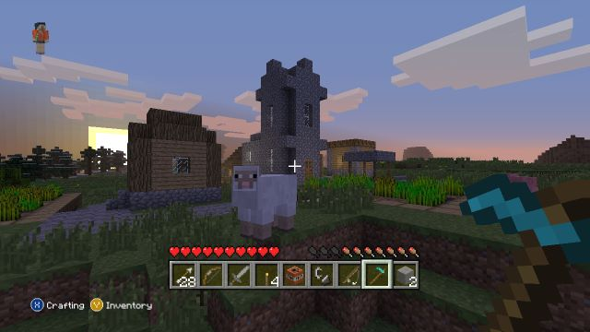

Stongholds

Java version

Strongholds are structures that occur naturally underground. They contain multiple rooms, corridors, stairs, doors and other aspects. Strongholds also contain a portal room with an unactivated End Portal, which when activated with twelve Eyes of Ender can be used to travel to The End. There are three strongholds per world, so strongholds are very rare. Strongholds can be located with the Eyes of Ender.
All Strongholds are located at random in a radius between 640 and 1152 blocks from the origin, 0/0.

Changes required for the Xbox version

We will limit Strongholds to one per world due to the limited map size, and the radius for placement of the stronghold will also be reduced to place it within the Xbox world. The End portal is added in Java version 1.0.0, so will not be in the Xbox 1.8.2

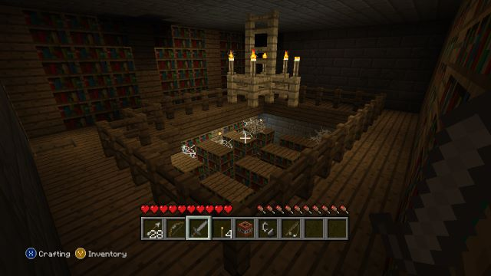

Abandoned Mineshafts

Java Version

Abandoned Mine Shafts are structures generated underground that consists of branching mining tunnels with wooden supports, and broken rails passing through it. This is also the only place in Minecraft where venomous Cave Spiders can be found. According to players, it is extremely easy to get lost in the labyrinth if you don't place torches or reminders. As of Minecraft 1.2, open areas generate with bridges instead of leaving floating platforms. They contain chests that may have rare items such as diamonds and Melon Seeds, the latter only being found naturally in mine shafts. They may also contain Iron Ingots, coal, pickaxes, and other useful items. They are likely to expose veins of coal, iron, and gold ore, and rarely, Lapis Lazuli and diamond ore.

Changes Required for the Xbox Version

As of Snapshot 12w05a, floating corridors will spawn on top of bridges made of wooden planks.

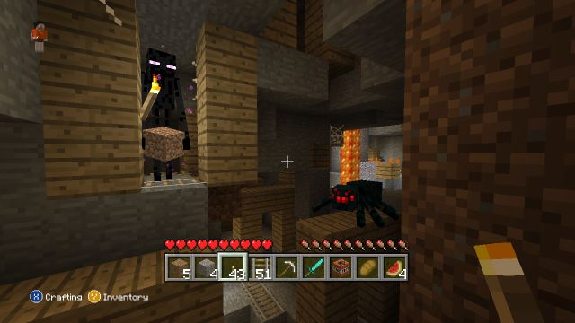

Ravines

Java Version

Ravines are tall, long cracks of air, usually measuring around 30 to 50 blocks in height. The width is barely a few blocks, usually no more than 5, sometimes making ravines hard to navigate from below. Ravines can have small ledges along the top, which are possible to travel along. Ravines can be found at any level, and also scarcely appear on the world surface, forming canyons. Such canyons do, from time to time, appear underwater where safe entry is possible. They can go very deep underground, sometimes spawning Slimes or even exposing Diamond Ore.
Ravines can connect to caves, dungeons, abandoned mines, and any other generated structures. Due to the large surface area of their walls, may also have water/lava flowing down them (either from a spring or an underground lake of the lava/water).

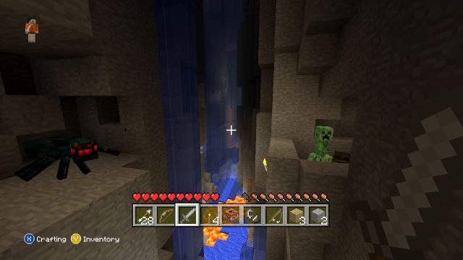

Superflat Land

This is a terrain generation feature from beyond 1.8.2, but it is very useful for Creative Mode, allowing players to start with flat terrain, and build whatever they want without needing to clear terrain out the way.
We’ll make the Overworld and the Nether world flat if the player selects this option.

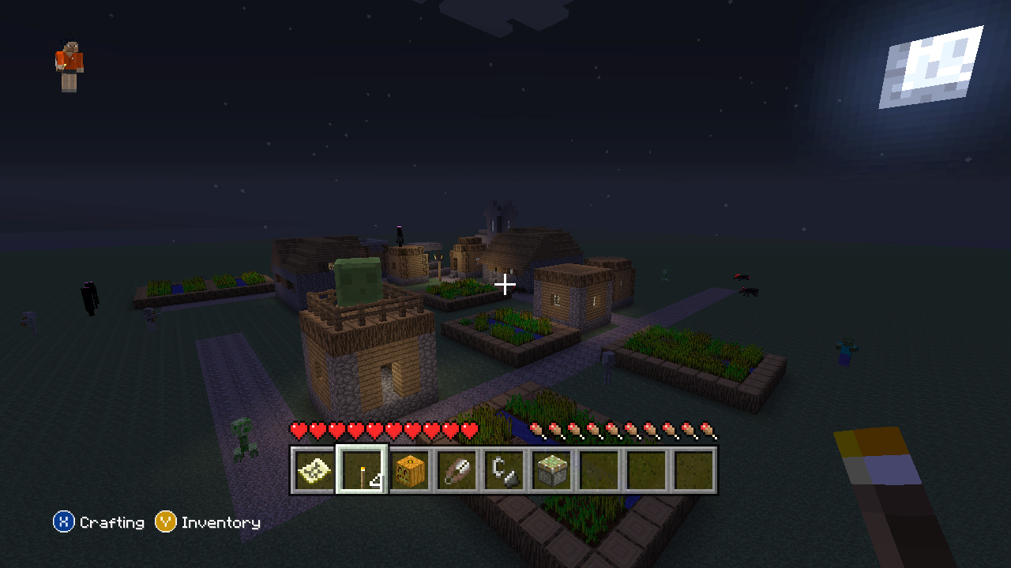

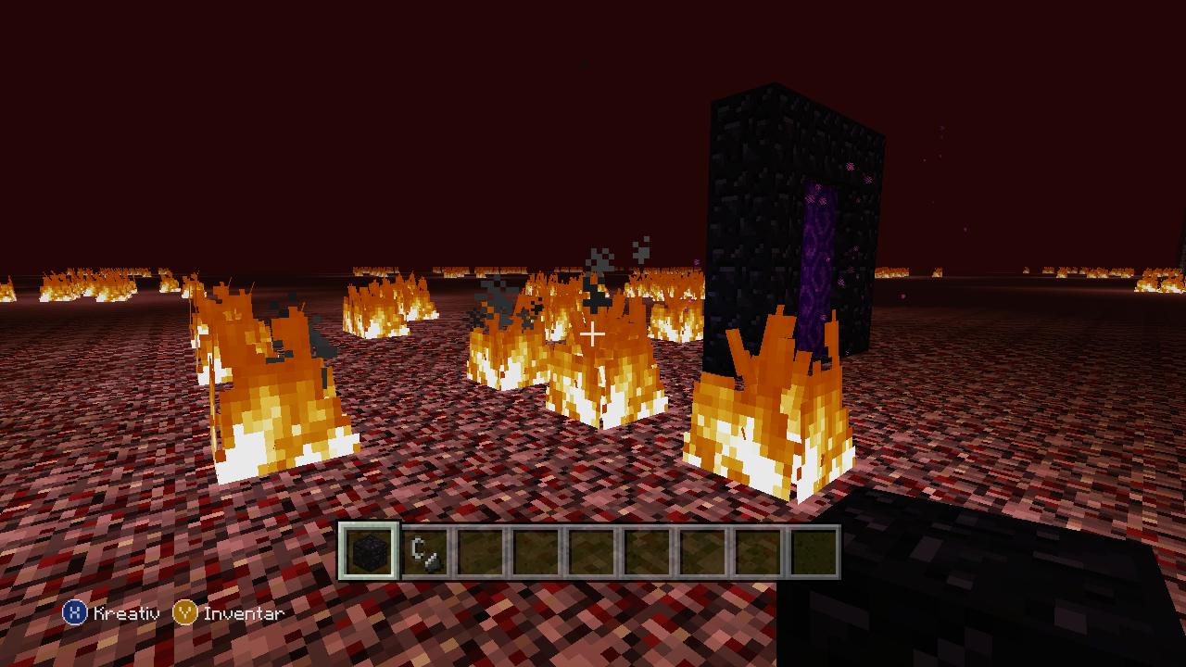

Bonus Chest

We’ll add this future option in with some set items and some random items. The set items will be materials & items that may not appear in the world, allowing the player to get all achievements within any world.

Load World

We’ll be adding options to the Load World menu to allow the player to choose whether they are launching the level in Survival Mode or Creative Mode.
Launching in Creative Mode will disable achievements being earned, and when launching in Survival Mode, we’ll check the level to see if it has ever been saved while in Creative Mode, and disable earning achievements if it has been.
We’ll also add a PVP toggle to the launch menu.
We’ll add a Rename Save option which will be accessible from the Saves List.

Host Options

There have been many requests for options for the host of a game. We will add the options below.

- Enable host to fly in a Survival game
- Enable host to turn off hunger for themselves
- Enable host to start a game with clients unable to mine until approved
- Give others ability to kick people, and mining privileges
- Toggle fire spreading
- Toggle dynamite
- Enable host to be invisible and unable to die

Some of these make sense as a host toggle option within the game too.

Moving things forward from later updates

Snow

Snow went missing from 1.8.2 and didn’t appear again until one of the recent weekly snapshots. We’ve added this back in to the Taiga biome.

Superflat Land

As mentioned in the Create World section, this is a terrain generation feature from beyond 1.8.2, but it is very useful for Creative Mode, allowing players to start with flat terrain, and build whatever they want without needing to clear terrain out the way.

Bonus Chest

As mentioned in the Create World section, we’ll add this future option in with some set items and some random items. The set items will be materials & items that may not appear in the world, allowing the player to get all achievements within any world.

Mining Changes

Changes were made to make a few things easier to mine. We’ll bring these changes forward.

Mushroom Stew

Mushroom Stew is changed to a shapeless recipe, allowing it to be made in 2x2 crafting, so no longer requiring the crafting table. We’ll move this forward to our 1.8.2 version.

Features changes

Order of features generation is changed to 1.2 version
Villages generate more often than in the Java version.

New Music discs

Adding the remaining music discs

Apple dropping from leaf block

New sound effects (the “Sound Update”)

Enabling all the new sounds.

Miscellaneous Changes

- The option to show or hide yourself on a map will be replaced by a combined option to show or hide in-game gamertags. The option will be made Host selectable only.
- ‘Equip’ tooltip for armour
- Add a quick move for fuel and ingredients in the Furnace menu.
- Display “Are you Sure” type message box when the player selects to exit without saving (customer requested).
- Add the missing Record for the jukebox (“Where We Are Now”).
- Segregate the DLC menu into each type of DLC to make it seem faster to load to the user.
- Display an autosave countdown for 5 seconds before an autosave kicks in (customer requested).

Removing from 1.8.2

Experience Points Bar and Experience Points

There’s no enchantment table in 1.8.2, so we’ll remove the experience points drops and the experience points bar.

